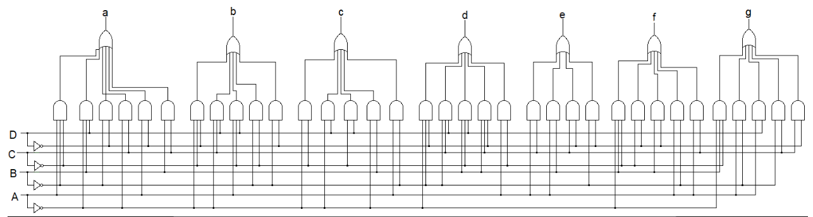

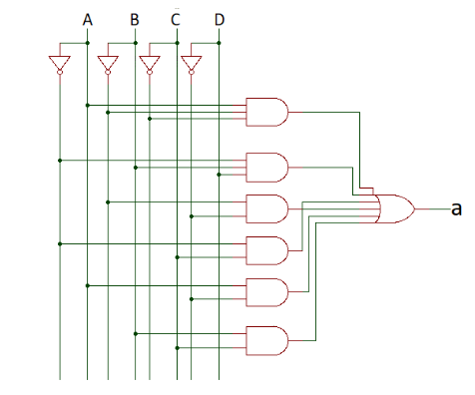

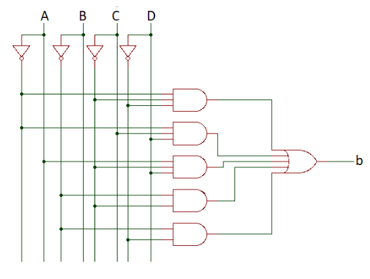

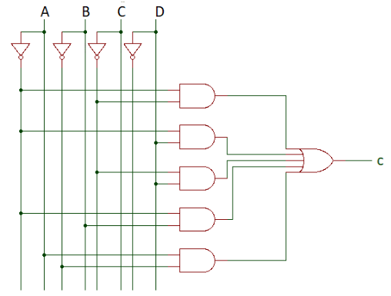

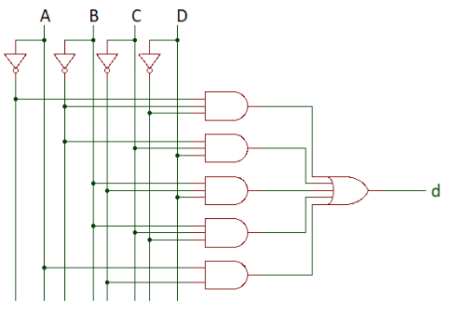

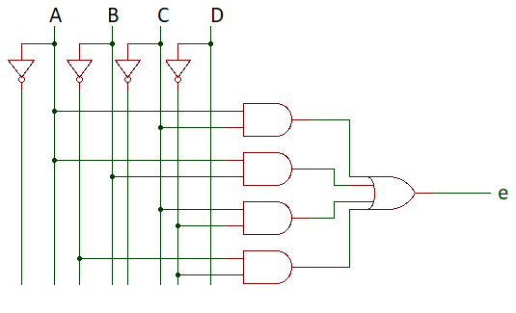

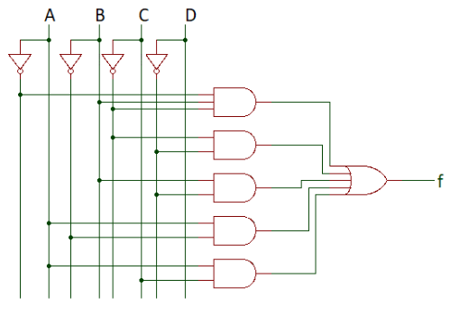

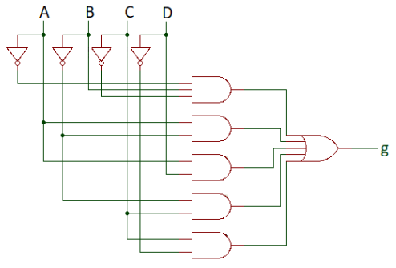­­

**//BCD to 7 segment display ///**

module seven_seg(a,b,c,d,e,f,g,A,B,C,D

);

output a,b,c,d,e,f,g;

input A,B,C,D;

wire y_D,y_B,y_C,y_A;

wire y_a31,y_a32,y_a21,y_a22,y_a23,y_a24,y_a33,y_a34;

wire y_b31,y_b32,y_b33,y_b21,y_b22,y_b34,y_b23;

wire y_c21,y_c22,y_c23,y_c24,y_c25,y_c31,y_c26;

wire y_d31,y_d32,y_d33,y_d34,y_d21,y_d35,y_d22;

wire y_e21,y_e22,y_e23,y_e24,y_e25,y_e26;

wire y_f31,y_f21,y_f22,y_f23,y_f24,y_f32,y_f25;

wire y_g31,y_g21,y_g22,y_g23,y_g24,y_g32,y_g25;

inv i1(y_D,D);

inv i2(y_C,C);

inv i3(y_B,B);

inv i4(y_A,A);

and3 a1(y_a31,A,y_B,y_C);

and3 a2(y_a32,y_A,B,D);

and2 a3(y_a21,y_B,y_D);

and2 a4(y_a22,y_A,C);

and2 a5(y_a23,A,y_D);

and2 a6(y_a24,B,C);

or3 a7(y_a33,y_a31,y_a32,y_a21);

or3 a8(y_a34,y_a22,y_a23,y_a24);

or2 a9(a,y_a33,y_a34);

and3 b1(y_b31,y_A,y_C,y_D);

and3 b2(y_b32,y_A,C,D);

and3 b3(y_b33,A,y_C,D);

and2 b4(y_b21,y_B,y_C);

and2 b5(y_b22,y_B,y_D);

or3 b6(y_b34,y_b31,y_b32,y_b33);

or2 b7(y_b23,y_b21,y_b22);

or2 b8(b,y_b34,y_b23);

and2 c1(y_c21,y_A,y_C);

and2 c2(y_c22,y_A,D);

and2 c3(y_c23,y_C,D);

and2 c4(y_c24,y_A,B);

and2 c5(y_c25,A,y_B);

or3 c6(y_c31,y_c21,y_c22,y_c23);

or2 c7(y_c26,y_c24,y_c25);

or2 c8(c,y_c31,y_c26);

and3 d1(y_d31,y_A,y_B,y_D);

and3 d2(y_d32,y_B,C,D);

and3 d3(y_d33,B,y_C,D);

and3 d4(y_d34,B,C,y_D);

and2 d5(y_d21,A,y_C);

or3 d6(y_d35,y_d31,y_d32,y_d33);

or2 d7(y_d22,y_d34,y_d21);

or2 d8(c,y_d35,y_d22);

and2 e1(y_e21,A,C);

and2 e2(y_e22,A,B);

and2 e3(y_e23,C,y_D);

and2 e4(y_e24,y_B,y_D);

or2 e5(y_e25,y_e21,y_e22);

or2 e5(y_e26,y_e23,y_e24);

or2 e6(e,y_e25,y_e26);

and3 f1(y_f31,y_A,B,y_C);

and2 f2(y_f21,y_C,y_D);

and2 f3(y_f22,B,y_D);

and2 f4(y_f23,A,y_B);

and2 f5(y_f24,A,C);

or3 f6(y_f32,y_f31,y_f21,y_f22);

or2 f7(y_f25,y_f23,y_f24);

or2 f8(f,y_f32,y_f25);

and3 g1(y_g31,y_A,B,y_C);

and2 g2(y_g21,A,y_B);

and2 g3(y_g22,A,D);

and2 g4(y_g23,y_B,C);

and2 g5(y_g24,C,y_D);

or3 g6(y_g32,y_g31,y_g21,y_g22);

or2 g7(y_g25,y_g23,y_g24);

or2 g8(g,y_g32,y_g25);

endmodule

**//inverter using CMOS**

module inv(Y,A);

output Y;

input A;

supply0 gnd;

supply1 vdd;

pmos p1(Y,vdd,A);

nmos n1(Y,gnd,A);

endmodule

**// 3-input AND gate using CMOS**

module and3(Y, A, B, C);

output Y;

input A, B, C;

supply0 gnd;

supply1 vdd;

wire a, b;

pmos p1(a, vdd, A);

pmos p2(b, a, B);

pmos p3(Y, b, C);

nmos n1(Y, gnd, A);

nmos n2(Y, gnd, B);

nmos n3(Y, gnd, C);

endmodule

**// 2-input AND gate using CMOS**

module and2(Y, A, B);

output Y;

input A, B;

supply0 gnd;

supply1 vdd;

wire a;

pmos p1(a, vdd, A);

pmos p2(Y, a, B);

nmos n1(Y, gnd, A);

nmos n2(Y, gnd, B);

endmodule

**// 3-input OR gate using CMOS**

module or3(Y, A, B, C);

output Y;

input A, B, C;

supply0 gnd;

supply1 vdd;

wire a, b;

pmos p1(a, vdd, A);

pmos p2(b, vdd, B);

pmos p3(Y, vdd, C);

nmos n1(Y, gnd, A);

nmos n2(Y, gnd, B);

nmos n3(Y, gnd, C);

endmodule

**// 2-input OR gate using CMOS**

module or2(Y, A, B);

output Y;

input A, B;

supply0 gnd;

supply1 vdd;

wire a;

pmos p1(a, vdd, A);

pmos p2(Y, a, B);

nmos n1(Y, gnd, A);

nmos n2(Y, gnd, B);

endmodule

**//BCD to 7 segment**

module segment7(

bcd,

seg

);

input [3:0] bcd;

output [6:0] seg;

reg [6:0] seg;

always @(bcd)

begin

case (bcd)

0 : seg = 7'b0000001;

1 : seg = 7'b1001111;

2 : seg = 7'b0010010;

3 : seg = 7'b0000110;

4 : seg = 7'b1001100;

5 : seg = 7'b0100100;

6 : seg = 7'b0100000;

7 : seg = 7'b0001111;

8 : seg = 7'b0000000;

9 : seg = 7'b0000100;

default : seg = 7'b1111111;

endcase

end

endmodule